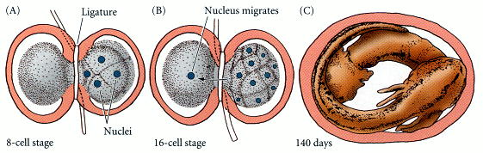
Figure 10.17. Spemann's demonstration of nuclear equivalence in newt cleavage. (A) When the fertilized egg of the newt Triturus taeniatus was constricted by a ligature, the nucleus was restricted to one-half of the embryo. The cleavage on that side of the embryo reached the 8-cell stage, while the other side remained undivided. (B) At the 16-cell stage, a single nucleus entered the as yet undivided half, and the ligature was constricted to complete the separation of the two halves. (C) After 140 days, each side had developed into a normal embryo. (After Spemann 1938.)

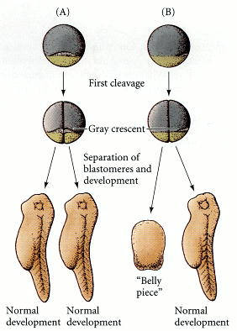
Figure 10.18. Asymmetry in the amphibian egg. (A) When the egg is divided along the plane of first cleavage into two blastomeres, each of which gets one-half of the gray crescent, each experimentally separated cell develops into a normal embryo. (B) When only one of the two blastomeres receives the entire gray crescent, it alone forms a normal embryo. The other half produces a mass of unorganized tissue lacking dorsal structures. (After Spemann 1938.)

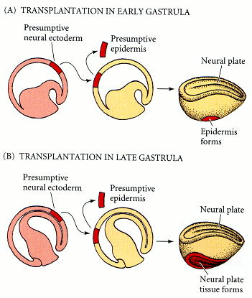
Figure 10.19. Determination of ectoderm during newt gastrulation. Presumptive neural ectoderm from one newt embryo is transplanted into a region in another embryo that normally becomes epidermis. (A) When the tissues are transferred between early gastrulas, the presumptive neural tissue develops into epidermis, and only one neural plate is seen. (B) When the same experiment is performed using late-gastrula tissues, the presumptive neural cells form neural tissue, thereby causing two neural plates to form on the host. (After Saxén and Toivonen 1962.)

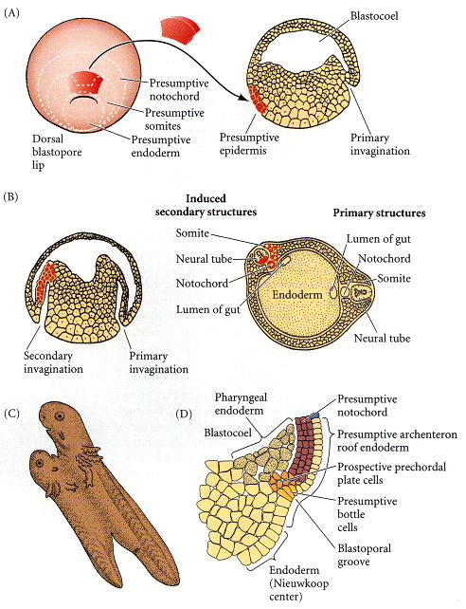
Figure 10.20. Organization of a secondary axis by dorsal blastopore lip tissue. (A) Dorsal lip tissue from an early gastrula is transplanted into another early gastrula in the region that normally becomes ventral epidermis. (B) The donor tissue invaginates and forms a second archenteron, and then a second embryonic axis. Both donor and host tissues are seen in the new neural tube, notochord, and somites. (C) Eventually, a second embryo forms that is joined to the host. (D) Structure of the dorsal blastopore lip region in an early Xenopus gastrula. (A-C after Hamburger 1988; D after Winklbauer and Schürfeld 1999 and Arendt and Nübler-Jung 1999.)

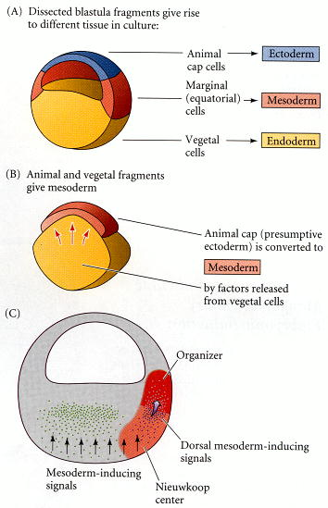
Figure 10.21. Summary of experiments by Nieuwkoop and by Nakamura and Takasaki (1970), showing mesodermal induction by vegetal endoderm. (A) Isolated animal cap cells become a mass of ciliated epidermis, isolated vegetal cells generate gutlike tissue, and isolated equatorial (marginal zone) cells become mesoderm. (B) If animal cap cells are combined with vegetal cap cells, many of the animal cells generate mesodermal tissue. (C) Model for mesoderm induction in Xenopus. A ventral signal (probably FGF2 or BMP4) is released throughout the vegetal region of the embryo. This induces the marginal cells to become mesoderm. On the dorsal side (away from the point of sperm entry), a signal is released by the vegetal cells of the Nieuwkoop center. This dorsal signal induces the formation of the Spemann organizer in the overlying marginal zone cells. The possible identity of this signal will be discussed later in this chapter. (C after De Robertis et al. 1992.)

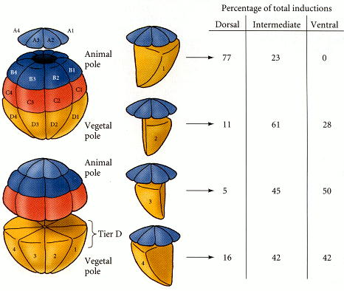
Figure 10.22. The regional specificity of mesoderm induction can be demonstrated by recombining cells of 32-cell Xenopus embryos. Animal pole cells were labeled with fluorescent polymers so that their descendants could be identified, then combined with individual vegetal blastomeres. The inductions resulting from these recombinations are summarized at the right. D1, the dorsalmost vegetal blastomere, was the most likely to induce the animal pole cells to form dorsal mesoderm. (After Dale and Slack 1987.)

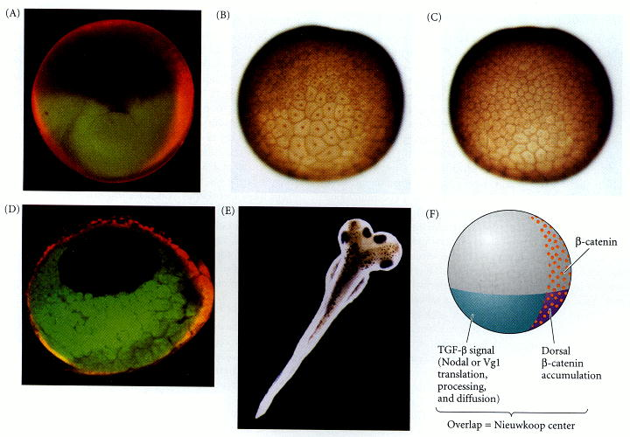
Figure 10.23. The role of Wnt pathway proteins in dorsal-ventral axis specification. (A-D) Differential translocation of β-catenin into Xenopus blastomere nuclei. (A) Early 2-cell stage of Xenopus, showing β-catenin (orange) predominantly at the dorsal surface. (B) Presumptive dorsal side of a Xenopus blastula stained for β-catenin shows nuclear localization. (C) Such nuclear localization is not seen on the ventral side of the same embryo. (D) β-catenin dorsal localization persists through the gastrula stage. (E) Dorsal axis formation caused by the injection of both blastomeres of a 2-cell Xenopus embryo with dominant inactive GSK-3. Dorsal fate is actively suppressed by wild-type GSK-3. (F) Irenic model whereby the Nieuwkoop center (characterized by siamois gene expression and the ability to induce dorsal mesoderm) is created by the synergy of the activation of β-catenin dorsally and the activation of the TGF-β signal vegetally. (A, D from R. T. Moon; B and C from Schneider et al. 1996, photographs courtesy of P. Hausen; E from Pierce and Kimelman 1995, photograph courtesy of D. Kimelman.)

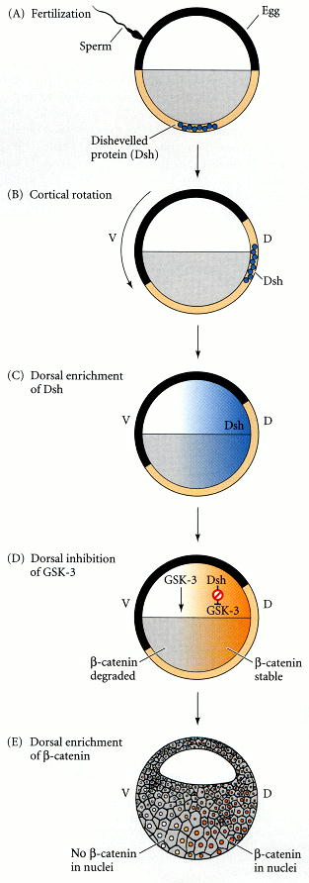
Figure 10.24. Model of the mechanism by which the Disheveled protein stabilizes β-catenin in the dorsal portion of the amphibian egg. (A) Disheveled (Dsh) associates with a particular set of proteins at the vegetal pole of the unfertilized egg. (B) Upon fertilization, these protein vesicles are translocated dorsally along subcortical microtubule tracks. (C) Disheveled is then released from its vesicles and is distributed in the future dorsal third of the 1-cell embryo. (D) Disheveled binds to and blocks the action of GSK-3, thereby preventing the degradation of β-catenin on the dorsal side of the embryo. (E) The nuclei of the blastomeres in the dorsal region of the embryo receive β-catenin, while the nuclei of those in the ventral region do not.

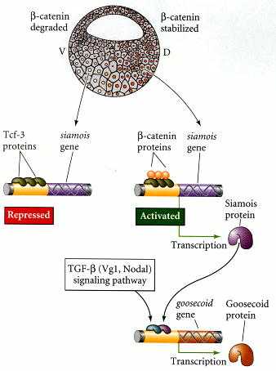
Figure 10.25. Summary of events hypothesized to bring about the induction of the organizer in the dorsal mesoderm. Cortical rotation causes the translocation of Disheveled protein to the dorsal side of the embryo. Dsh binds GSK-3, thereby allowing β-catenin to accumulate in the future dorsal portion of the embryo. During cleavage, β-catenin enters the nuclei and binds with Tcf3 to form a transcription factor that activates genes encoding proteins such as Siamois. Siamois and Lim-1, a transcription factor activated by the TGF-β pathway, function together to activate the goosecoid gene in the organizer. Goosecoid is a transcription factor that can activate genes whose proteins are responsible for the organizer's activities. (After Moon and Kimelman 1998).

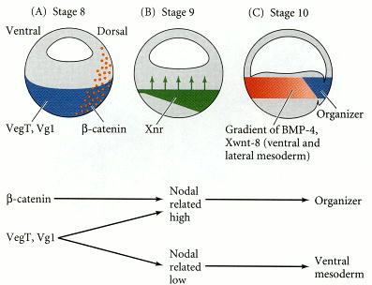
Figure 10.26. Model for mesoderm induction and organizer formation by the interaction of β-catenin and TGF-β proteins. (A) At late blastula stages, Vg1 and VegT are found in the vegetal hemisphere, while β-catenin is located in the dorsal region. (B) β-catenin acts synergistically with Veg1 and VegT to activate the Xenopus Nodal-related (Xnr) genes. This creates a gradient of Xnr proteins across the endoderm, highest in the dorsal region. (C) The mesoderm is specified by the gradient of Xnr proteins. Mesodermal regions with little or no Xnr proteins have high levels of BMP-4 and Xwnt-8; they become ventral mesoderm. Those having intermediate concentrations of Xnrs become lateral mesoderm. Where there is a high concentration of Xnrs, the goosecoid gene and other dorsal mesodermal genes are activated, and the mesodermal tissue becomes the organizer. (These results may explain the activity concentration experiments mentioned in Chapter 3.) (After Agius et al. 2000.)

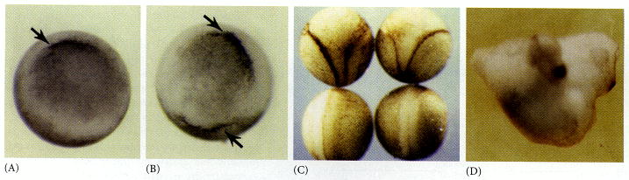
Figure 10.27. Ability of goosecoid mRNA to induce a new axis. (A) At the gastrula stage, a control embryo (either uninjected or given an injection of goosecoid-like mRNA but lacking the homeobox) has one dorsal blastopore lip. (B) An embryo whose ventral vegetal blastomeres were injected at the 16-cell stage with goosecoid message. Note the secondary dorsal lip. (C) The top two embryos, which were injected with goosecoid mRNA, show two axes; the bottom two control embryos do not. In the upper embryos, two dorsal axes are seen. (D) Twinned embryo produced by goosecoid injection. Two complete sets of head structures have been induced. (After Cho et al. 1991a; Niehrs et al. 1993; photographs courtesy of E. De Robertis.)

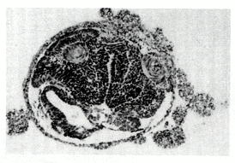
Figure 10.28. Neural structures induced in presumptive ectoderm by newt dorsal lip tissue, separated from the ectoderm by a Nucleopore filter with an average pore diameter of 0.05 mm. Anterior neural tissues are evident, including some induced eyes. (From Toivonen 1979; photograph courtesy of L. Saxén.)

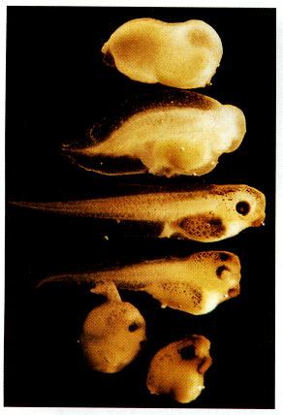
Figure 10.29. Rescue of dorsal structures by Noggin protein. When Xenopus eggs are exposed to ultraviolet radiation, cortical rotation fails to occur, and the embryos lack dorsal structures (top). If such an embryo is injected with noggin mRNA, it develops dorsal structures in a dosage-related fashion (top to bottom). If too much noggin message is injected, the embryo produces dorsal anterior tissue at the expense of ventral and posterior tissue, becoming little more than a head (bottom). (Photograph courtesy of R. M. Harland.)

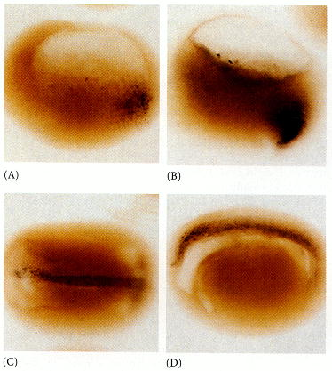
Figure 10.30. Localization of the noggin mRNA in the organizer tissue, shown by in situ hybridization. (A) At gastrulation, noggin message (dark areas) accumulates in the dorsal marginal zone. (B) When cells involute, noggin mRNA is seen in the dorsal blastopore lip. (C) During convergent extension, noggin message is expressed in the precursors of the notochord, prechordal plate, and pharyngeal endoderm, which extend (D) beneath the ectoderm in the center of the embryo. (Photographs courtesy of R. M. Harland.)

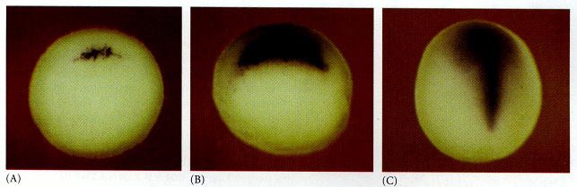
Figure 10.31. Chordin mRNA localization. (A) Whole-mount in situ hybridization shows that just prior to gastrulation, chordin message (dark area) is expressed in the region that will become the dorsal blastopore lip. (B) As gastrulation begins, Chordin is expressed at the dorsal blastopore lip. (C) In later stages of gastrulation, Chordin message is seen in the organizer tissues. (From Sasai et al. 1994; photographs courtesy of E. De Robertis.)

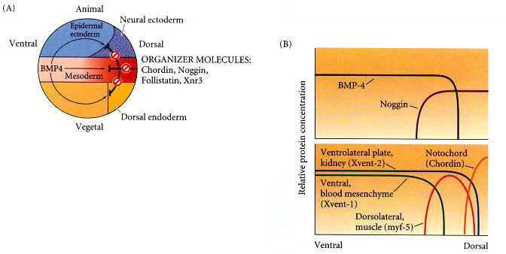
Figure 10.32. Model for the action of the organizer. (A) BMP4 (and certain other molecules) is a powerful ventralizing factor. Organizer proteins such as Chordin, Noggin, and Follistatin block the action of BMP4. The antagonistic effects of these proteins can be seen in all three germ layers. (B) BMP4 may elicit the expression of different genes in a concentration-dependent fashion; in that way, the mesoderm could be patterned. BMP4 is expressed throughout the marginal zone (prospective mesoderm) except in the dorsal domain. Noggin and Chordin are expressed in the dorsal domain. These proteins bind to BMP4 and prevent it from reaching the mesodermal cells. In the regions of noggin and chordin expression, BMP4 is totally prevented from binding, and these tissues become notochord (organizer) tissue. Slightly farther away from the organizer, myf5, a marker for the dorsolateral muscles, is activated. As more and more BMP4 molecules are allowed to bind to the cells, Xvent2 (ventrolateral) and Xvent1 (ventral) genes become expressed. (After Dosch et al. 1997.)

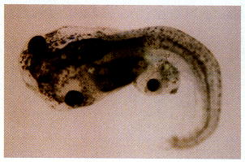
Figure 10.34. Cerberus mRNA injected into a single D4 (ventral vegetal) blastomere of a 32-cell Xenopus embryo induces head structures as well as a duplicated heart and liver. The secondary eye (a single cyclopic eye) and olfactory placode can be readily seen. (From Bouwmeester et al. 1996; photograph courtesy of E. M. De Robertis.)

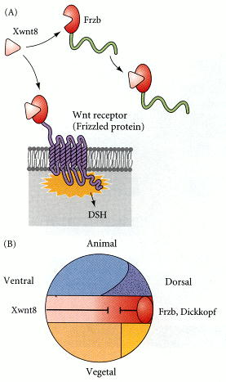
Figure 10.35. Xwnt8 is capable of ventralizing the mesoderm and preventing anterior head formation in the ectoderm. (A) Frzb is a protein secreted by the anterior region of the organizer. It binds to Xwnt8 before that inducer can bind to its receptor. Frzb resembles the Wnt-binding domain of the Wnt receptor (Frizzled protein), but is a soluble molecule. (B) Xwnt8 is made throughout the marginal zone.

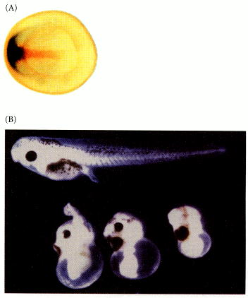
Figure 10.36. Frzb expression and function. (A) Double in situ hybridization localizing frzb (dark blue) and chordin (brown) messages. frzb mRNA can be seen to be transcribed in the head endomesoderm of the organizer, but not in the notochord (where chordin is expressed). (B) Microinjection of frzb mRNA into the marginal zone leads to the inhibition of trunk formation. (From Leyns et al. 1997; photographs courtesy of E. M. De Robertis.)

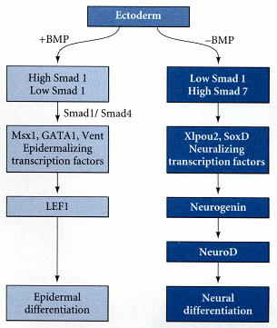
Figure 10.37. Hypothetical pathways differentiating ectoderm into epidermis or neural ectoderm. In the presence of BMP signaling, epidermalizing transcription factors are generated, leading to the activation of the pathway enabling the cell to become an epidermal keratinocyte. In the absence of BMP signaling, neuralizing transcription factors are produced. These factors activate the gene for neurogenin. Neurogenin acts as a transcription factor to activate the NeuroD gene, and NeuroD acts as a transcription factor to cause the differentiation of the cell into a neuron.

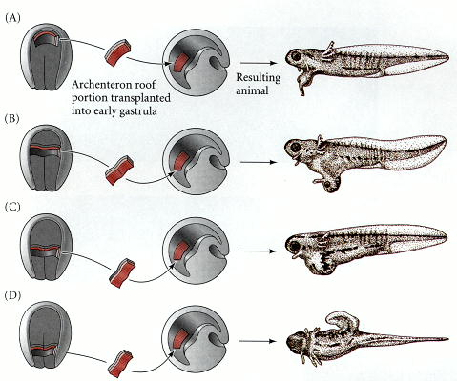
Figure 10.39. Regional specificity of induction can be demonstrated by implanting different regions (color) of the archenteron roof into early Triturus gastrulae. The resulting embryos develop secondary dorsal structures. (A) Head with balancers. (B) Head with balancers, eyes, and forebrain. (C) Posterior part of head, deuterencephalon, and otic vesicles. (D) Trunk-tail segment. (After Mangold 1933.)

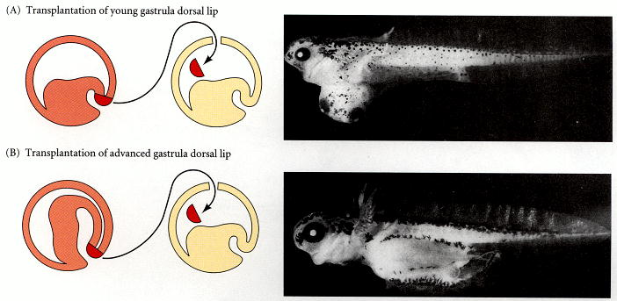
Figure 10.40. Regionally specific inducing action of the dorsal blastopore lip. (A) Young dorsal lips (which will form the anterior portion of the organizer) induce anterior dorsal structures when transplanted into early newt gastrulae. (B) Older dorsal lips transplanted into early newt gastrulae produce more posterior dorsal structures. (From Saxén and Toivonen 1962; photographs courtesy of L. Saxén.)

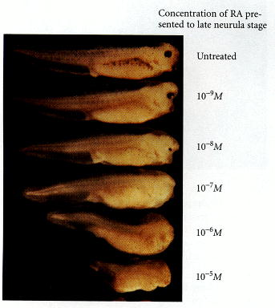
Figure 10.41. Effects of RA and FGF on the anterior-posterior axis. Late neurula embryos exposed to progressively higher concentrations of retinoic acid (and allowed to grow until the controls reached tadpole stage) lose posterior regions of the embryo (as well as having eye deformities). (From Ruiz i Altaba and Jessell 1991; photograph courtesy of T. Jessell.)

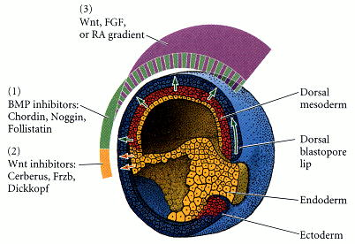
Figure 10.42. Model for the organizer function and axis specification in Xenopus gastrula. (1) BMP inhibitors from organizer tissue (dorsal mesoderm and pharyngeal mesendoderm) block the formation of epidermis, ventrolateral mesoderm, and ventrolateral endoderm. (2) Wnt inhibitors in the anterior of the organizer (pharyngeal mesendoderm) allow the induction of head structures. (3) A gradient of caudalizing factors (eFGF, retinoic acid, and/or Wnt3a) specify the regional expression of Hox genes.

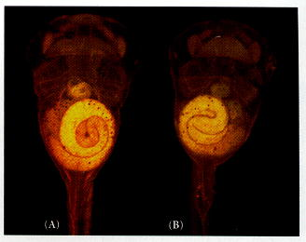
Figure 10.43. Pitx2 determines the direction of heart looping and gut coiling. (A) Wild-type (stage 45) Xenopus tadpole viewed from the ventral side, showing rightward heart looping and counterclockwise gut coiling. (B) If an embryo is injected with Pitx2 so that this protein is present in the mesoderm of both the right and left sides (instead of just the left side), heart looping and gut coiling are random with respect to each other. Sometimes this results in complete reversals, as in this embryo, in which the heart loops to the left and the gut coils in a clockwise manner. (From Ryan et al. 1998; photograph courtesy of J. C. Izpisúa-Belmonte.)

